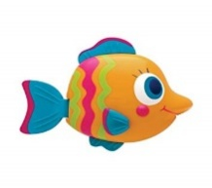

Ms. Canchani’s Supply List

Dear Parents/Guardians,

Welcome to first grade! This year, we will need the following ítems:

* 1 1-inch Binder with a clear front pocket (home/school binder)
* 1 standard hard plastic pencil box
* 1 pack of 24 crayons
* 1 dozen #2 pencils
* 1 pack of pink erasers
* 1 pack of glue sticks
* 4 pronged folders (solid colors please)
* 2 **primary** composition notebooks
* 1 water bottle (**No** Stanleys, please)
* Headphones (over the ears, **no** earbuds)

In addition, the classroom will also need the following ítems, if you are able to donate:

* Lysol Disinfectant Spray
* Bandaids (various sizes)
* Hand sanitizer
* Tissues
* Clorox/Disinfectant Wipes
* EXPO Dry Erase Markers

Thank you very much for making sure our class is prepared for the year!



 Sincerely,

Ms. Canchani